PROJECT DOCUMENTATION

1. Introduction

Project Title : Educational Organisation Using ServiceNow

Team details :
• N Sheena (Team Leader & Lead Architect): Project Manager; responsible for table creation (Salesforce, Admission, Progress), final documentation, and system demo.
• Ummadi Dinesh (UI/UX Developer): Responsible for form designing and layout configuration to ensure user-friendly data entry.
• T Lahari (Automation Developer): Responsible for implementing Client Scripts and the automation logic for result calculations.
• Borugutta Thasmiya Sultana (Workflow & Quality Engineer): Responsible for the Process Flow Formatter and leading the functional testing phase.

2. Project Overview

Purpose
The purpose of this project is to design and implement a ServiceNow-based application for managing educational organization processes such as admissions and student academic progress. The system aims to reduce manual effort, improve data accuracy, and provide a centralized platform for administrative operations.

Features
- Custom tables for Salesforce, Admission, and Student Progress
- Automated number generation using Number Maintenance
- Dynamic forms with structured layouts
- Auto-population of fields using Client Scripts
- Automatic calculation of total marks, percentage, and result
- Process Flow formatter for tracking admission status

3. Architecture
• Frontend: Built using ServiceNow UI Pages, Form Design, and Layout tools to create clean, responsive student forms.
• Backend: Logic implemented via Client Scripts (onChange and onLoad) to handle dynamic form behaviors.
• Database: Platform-native schema consisting of three primary tables: Salesforce, Admission, and Student Progress, linked via reference relationships.

4. Setup Instructions

Prerequisites
- ServiceNow Personal Developer Instance
- Internet browser
- Basic knowledge of ServiceNow Administration

Installation / Setup
- Create a ServiceNow Personal Developer Instance
- Log in with administrator credentials
- Create an Update Set for the project
- Configure custom tables and fields
- Design forms and layouts
- Implement process flows and client scripts

5. Folder Structure

Educational Organisation/
├── 📂 Data Model (Tables)
│ ├── 📄 Salesforce [u_salesforce]
│ ├── 📄 Admission [u_admission]
│ └── 📄 Student Progress [u_student_progress]
├── 📂 Forms & UI
│ ├── 📋 Form Design (Salesforce)
│ ├── 📋 Form Design (Admission)
│ ├── 📋 Form Design (Student Progress)
│ └── 📈 Process Flow Formatter (Admission)
├── 📂 Client Side Logic (Client Scripts)
│ ├── 📜 Auto-Generate Admission Number (onLoad)
│ ├── 📜 Auto-Populate Student Data (onChange)
│ ├── 📜 Calculate Marks & Results (onChange)
│ ├── 📜 Address Auto-fill based on PIN (onChange)
│ └── 📜 Alert on Submission (onSubmit)
└── 📂 Security & Access
├── 📜 Disable Fields After Finalization (onChange)
└── 📜 Role-Based Access Controls (ACLs)

6. Running the Application
The application runs on the ServiceNow cloud platform.
Users can access it by logging into the ServiceNow instance URL and navigating to the configured application modules.

7. API Documentation
The project uses ServiceNow Table APIs for internal data handling. These APIs enable secure interaction with table records and support CRUD operations within the platform.

8. Authentication
Authentication and authorization are handled by ServiceNow role-based access control. Users log in using ServiceNow credentials, and access permissions are assigned based on roles such as administrator or staff.

9. User Interface
The user interface consists of:
- Custom forms for Salesforce, Admission, and Student Progress
- Process Flow formatter for admission status
- Auto-calculated and read-only fields
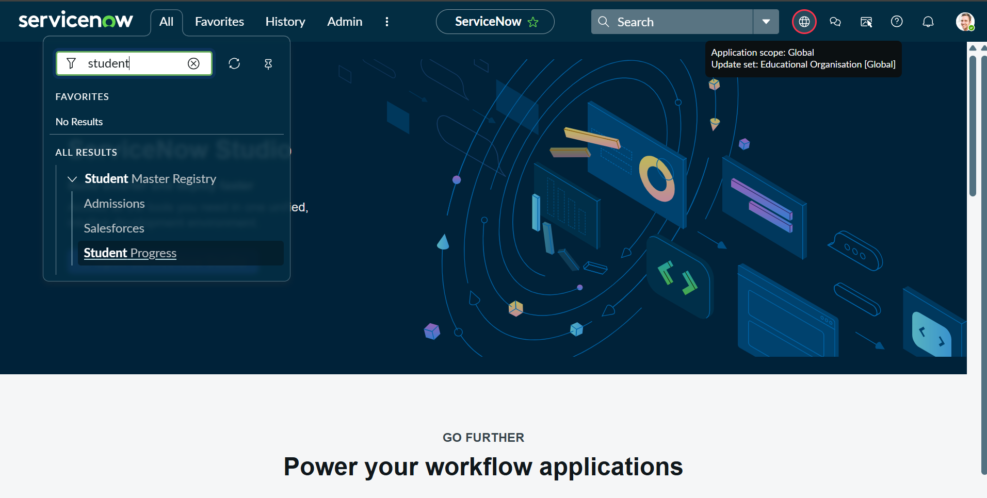 Fig 1: Application Navigator showing custom modules and table structure. 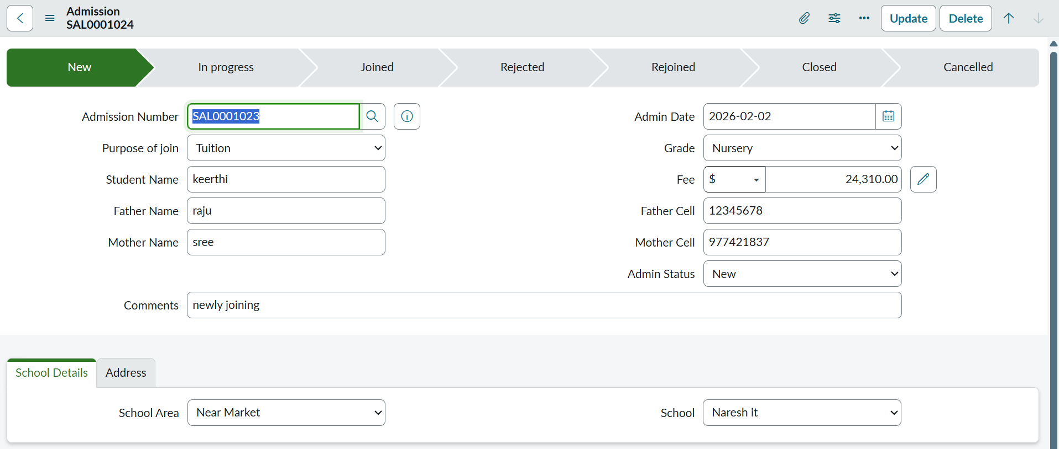 Fig 2: Admission form highlighting the Process Flow Formatter.

10. Testing
Testing was performed to ensure:
- Accurate auto-population of fields
- Correct calculation of total marks, percentage, and result
- Proper disabling of auto-calculated fields
- Smooth functioning of process flow stages

11. Screenshots or Demo

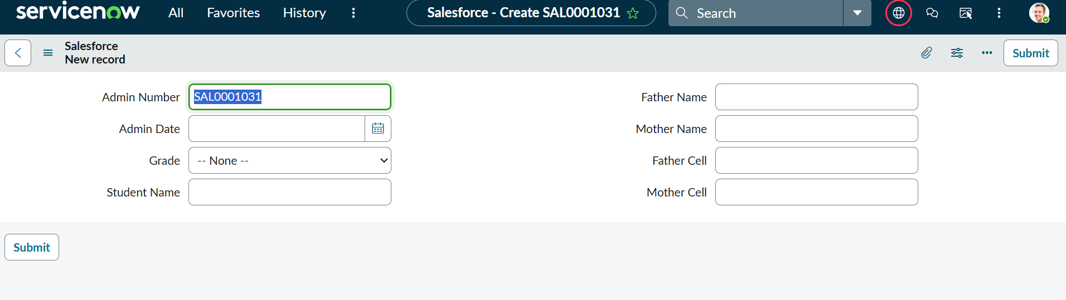
Fig 3: Salesforce master form for student record creation.

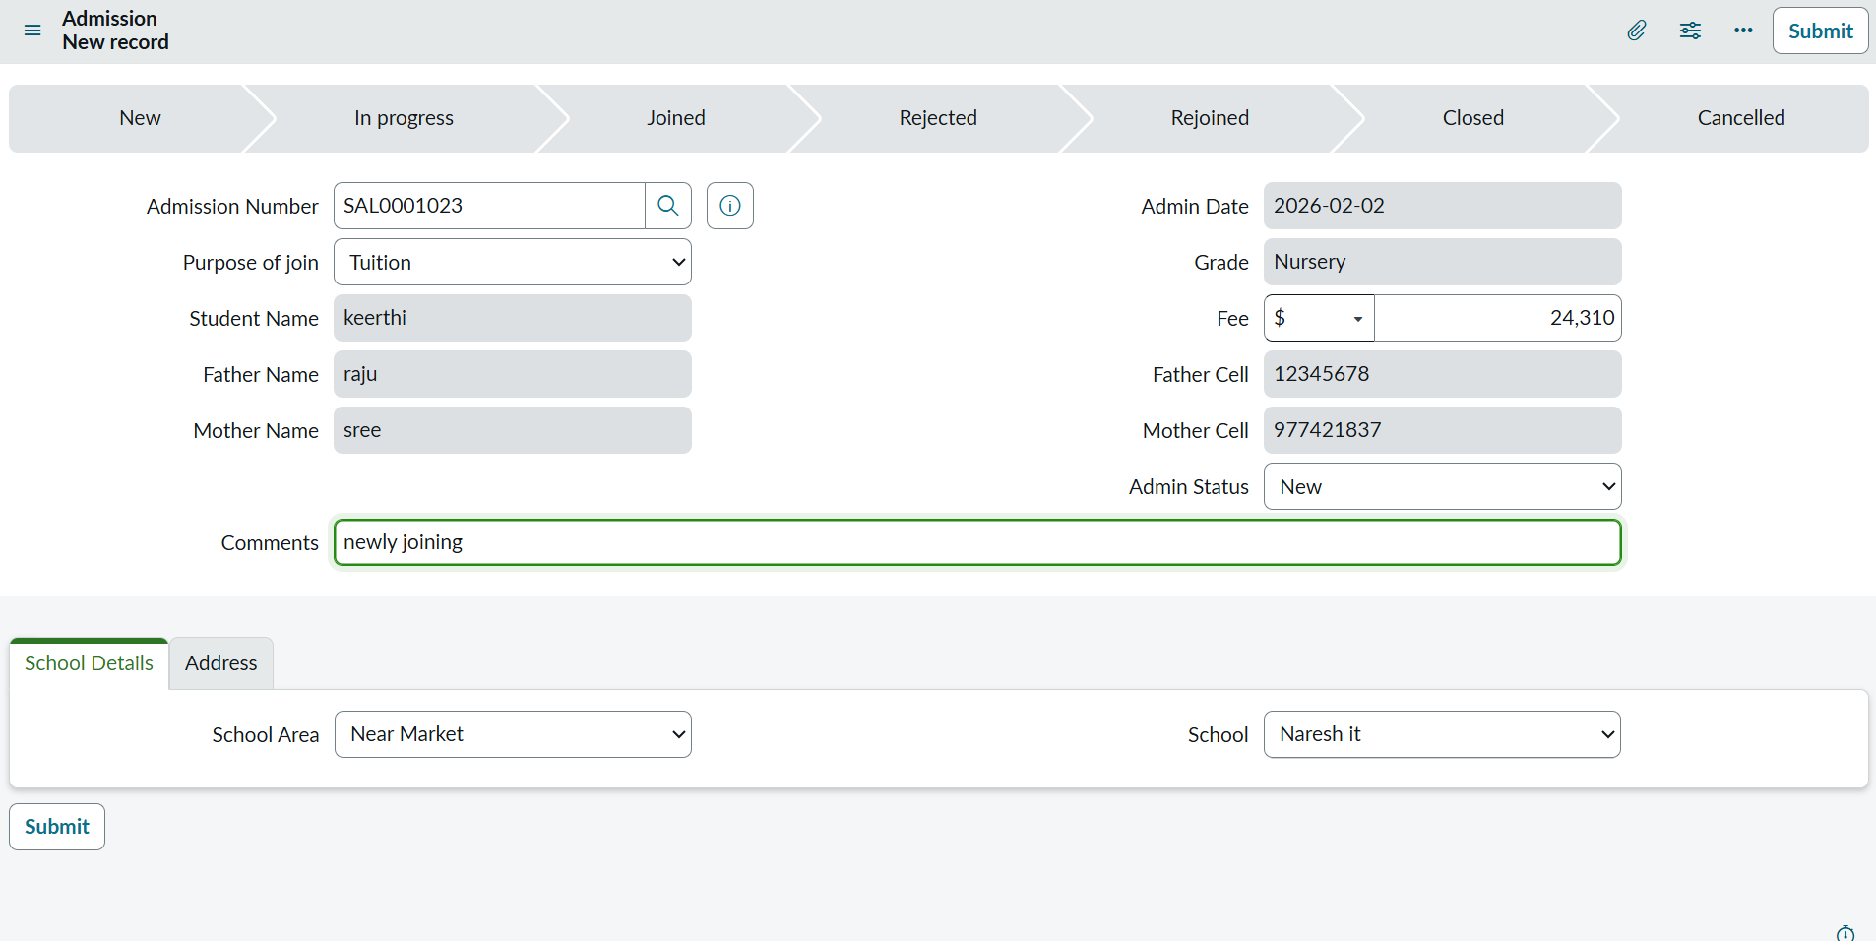
Fig 4: Live Admission form with auto-populated data.
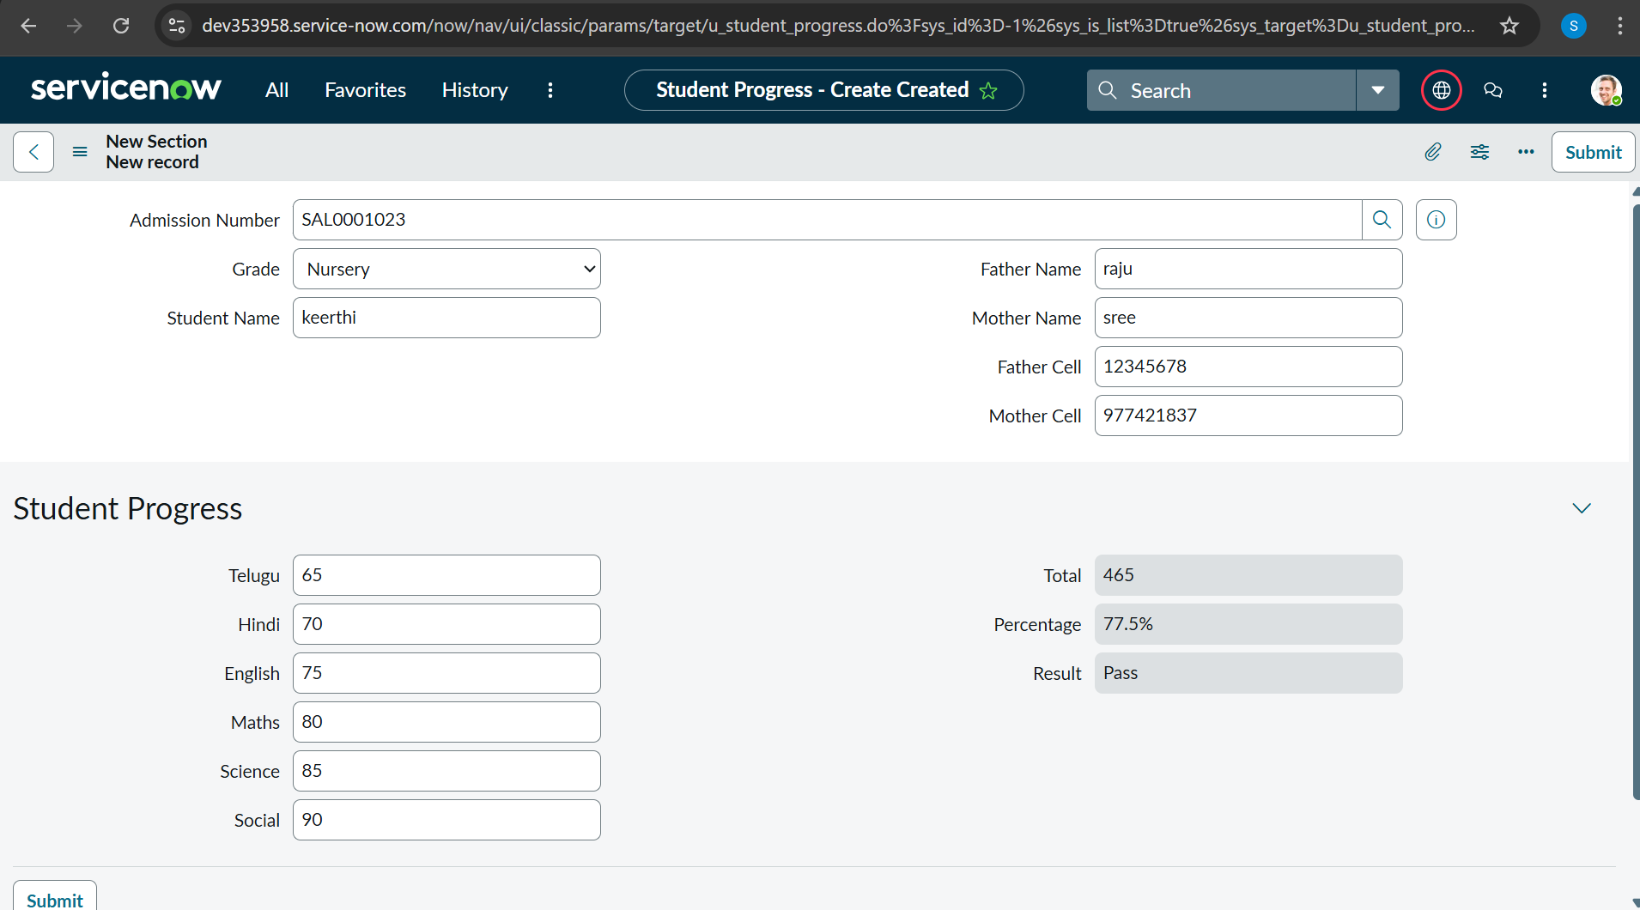
Fig 5: Student Progress record with automated result calculations.
Demo link :
https://drive.google.com/file/d/1Qem9byDvimuuUPFkOqc5f4jKRNmSExn5/view?usp=sharing

12. Known Issues
• Advanced UI customization is limited
• Requires stable internet connectivity
• Basic ServiceNow knowledge is required for configuration

13. Future Enhancements
• Integration with notification services
• Dashboard and reporting features
• Role-based portals for students and faculty
• Additional academic management modules

